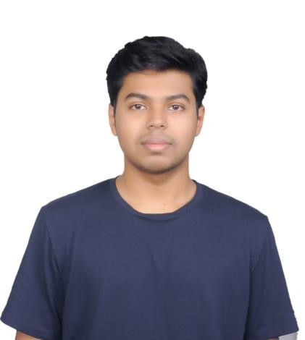

ARYAN GUPTE

MBA TECH (COMPUTER ENGINEER
)

PROFILE

I am very passionate about learning

new
thing related to the field of

science and
technology.

CONTACT

PHONE:

+91 9322084651

ADDRESS:

E
-
Wing,

Vasant

Fiona,

Majiwada,

Thane

)
W
(

–

,
400601
Maharashtra, India

DOB:

09.10.2003

EMAIL:

aryan9oct@gmail.com

HOBBIES

1.

Cycling,

2.

Drawing.

3.

Travelling.

4.

Cooking,

EDUCATION

OUR OWN ENGLISH HIGH SCHOOL
–

BOY’S BRANCH,
SHARJAH, UAE

2010

–

2020

I have done my
secondary education from Central Board of Secondary
Education (CBSE), New Delhi securing 88.2 percentage.

CITY INTERNATIONAL SCHOOL, PUNE, MAHARASHTRA, INDIA

2020
–

2022

I have completed my higher secondary education from Central Board of
Secondary Education (CBSE), New Delhi in science (PCMB) stream
securing 78 percentage.

SKILLS

1.

Leadership.

2.

Fluent communication in English, Marathi and Hindi
language.

3.

Have knowledge of basics of Microsoft Excel.

4.

Have knowledge of basic of Engineering drawing on software
like AutoCad.

5.

Knows basic concept of computer languages like C++,
Python, HTML.

6.

Have experience in making formal presentations.

